KING FAISAL UNIVERSITY CHAD — ACADEMIC INFORMATION SYSTEM (KFU-AIS)
VERSION 2.0

A PROJECT REPORT

Submitted by

Mahamat Kher – 25MCD 10068

in partial fulfillment for the award of the degree of

MASTER OF COMPUTER APPLICATION
IN
Data Science

Chandigarh University
April 2026

BONAFIDE CERTIFICATE
Certified that this project report "KING FAISAL UNIVERSITY CHAD — ACADEMIC INFORMATION SYSTEM (KFU-AIS) v2.0" is the bonafide work of Ms. HARMANJOT KAUR who carried out the project work under my/our supervision.

SIGNATURE  Dr.Aman Preet Kaur Sandhu  HEAD OF THE DEPARTMENT  Computing | SIGNATURE  Ms. HARMANJOT KAUR

Submitted for the project viva-voce examination held on ___________________

INTERNAL EXAMINER | EXTERNAL EXAMINER



ABSTRACT
This report presents the design, development, and implementation of the King Faisal University Academic Information System (KFU-AIS) v2.0, a full-stack web-based university management platform built for King Faisal University, Republic of Chad. The system digitalizes and centralizes all core academic and administrative operations of the university into a single secure portal accessible by three distinct user roles: Administrator, Faculty, and Student.
The system is architected on a robust Java-based backend using Jakarta Servlets deployed on Apache Tomcat 10.1, with a MySQL 8.0 relational database and a lightweight frontend built with pure HTML5, CSS3, and Vanilla JavaScript — making it ideal for deployment in low-bandwidth environments. The system encompasses 15 functional modules including Authentication, Student Management, Faculty Management, Course Management, Timetable, Attendance, Results, Assignments, Fee Management, Hostel Management, Library Management, and a Notice Board. The database design consists of 16 normalized tables with 22 foreign key constraints ensuring referential integrity. Security is enforced through PreparedStatement-based SQL injection prevention, server-side session management, role-based access control, and transactional database operations with rollback on failure.
The resulting system is a scalable, secure, and deployable academic information solution tailored to the operational needs of King Faisal University, Chad.

TABLE OF CONTENTS
CHAPTER 1. INTRODUCTION 8
1.1. Identification of Client / Need / Relevant Contemporary Issue 8
1.2. Identification of Problem 8
1.3. Identification of Tasks 8
1.4. Timeline 9
1.5. Organization of the Report 9
CHAPTER 2. LITERATURE REVIEW / BACKGROUND STUDY 10
2.1. Timeline of the Reported Problem 10
2.2. Existing Solutions 10
2.3. Bibliometric Analysis 11
2.4. Review Summary 11
2.5. Problem Definition 11
2.6. Goals / Objectives 11
CHAPTER 3. DESIGN FLOW / PROCESS 13
3.1. Evaluation & Selection of Specifications / Features 13
3.2. Design Constraints 13
3.3. Analysis of Features and Finalization Subject to Constraints 13
3.4. Design Flow 14
3.5. Design Selection 14
3.6. Implementation Plan / Methodology 14
CHAPTER 4. RESULTS ANALYSIS AND VALIDATION 19
4.1. Implementation of Solution 19
4.1.1. Authentication & Session Management 19
4.1.2. Student Management 19
4.1.3. Attendance Management 19
4.1.4. Results Management 19
4.1.5. Library Management 20
4.1.6. Hostel Management 20
4.1.7. Security Validation 20
4.1.8. Module Implementation Summary 20
4.2. System Interface Screenshots 21
4.2.1. Login Page (Figure 4.1) 21
4.2.2. Administrator Dashboard (Figure 4.2) 22
4.2.3. Faculty Dashboard (Figure 4.3) 24
4.2.4. Student Dashboard (Figure 4.4) 25
CHAPTER 5. CONCLUSION AND FUTURE WORK 27
5.1. Conclusion 27
5.2. Future Work 27
REFERENCES 29
APPENDIX 30
1. Plagiarism Report 30
2. Design Checklist 30
USER MANUAL 31
System Requirements 31
Setup Instructions 31
Login Instructions 31
Module Navigation 31

LIST OF FIGURES
Figure 4.1 — KFU-AIS Login Page (login.html)
Figure 4.2 — KFU-AIS Administrator Dashboard (admin-dashboard.html)
Figure 4.3 — KFU-AIS Faculty Dashboard (faculty-dashboard.html)
Figure 4.4 — KFU-AIS Student Dashboard (student-dashboard.html)

LIST OF TABLES
Table 3.1 — Technology Stack Summary
Table 3.2 — System Modules Overview
Table 3.3 — Database Table Descriptions
Table 3.4 — User Role & Access Matrix
Table 3.5 — Project File Structure
Table 3.6 — Default Login Credentials
Table 4.1 — Module Implementation Status

CHAPTER 1. INTRODUCTION

1.1. Identification of Client / Need / Relevant Contemporary Issue
King Faisal University (KFU), located in the Republic of Chad, is a rapidly growing higher education institution that serves students across eight academic departments including Computer Science, Engineering, Medicine, Law, and Business Administration. Like many universities in Sub-Saharan Africa, KFU historically relies on manual, paper-based administrative processes for managing student records, attendance, examinations, fees, hostels, and library operations.
In an era where digital transformation of education is a global priority, the absence of a centralized academic information system creates significant operational bottlenecks: data duplication, delayed reporting, error-prone manual record-keeping, and difficulty in providing timely academic feedback to students. There is therefore a critical and contemporary need to develop a modern, web-based Academic Information System that can operate efficiently even in low-bandwidth environments.

1.2. Identification of Problem
The core problems faced by King Faisal University that necessitate this system are as follows:
- No centralized database for student, faculty, or course records, leading to fragmented data management across departments.
- Manual attendance tracking is error-prone and time-consuming, and students have no real-time visibility into their attendance status.
- Results and grade computation are performed manually, with delayed access for students and no CGPA tracking.
- Fee payment records are maintained on paper with no digital payment tracking or due-date alerting.
- Hostel room allocation and library book issuance/return are untracked, leading to resource mismanagement.
- Faculty have no digital platform to post assignments or receive submissions, causing logistical inefficiencies.
- There is no centralized notice board, making institutional communication slow and unreliable.

1.3. Identification of Tasks
To address the identified problems, the following tasks were undertaken in this project:
- Design a normalized relational database (MySQL 8.0) with 16 tables and 22 foreign key constraints to support all university operations.
- Develop a Java-based backend using Jakarta Servlet API 6.0 on Apache Tomcat 10.1 following the MVC (Model-View-Controller) architecture.
- Build a pure HTML5/CSS3/JavaScript frontend requiring no external frameworks for lightweight deployment.
- Implement 15 functional modules covering Authentication, Student, Faculty, Course, Timetable, Attendance, Results, Assignments, Fees, Hostel, Library, Notices, and Dashboard.
- Enforce role-based access control for three user roles: Administrator, Faculty, and Student.
- Implement comprehensive security measures including SQL injection prevention, session management, input validation, and transactional operations.
- Test and validate all modules for functional correctness and security compliance.

1.4. Timeline
The project was executed in a structured timeline across four phases:
Phase | Activities | Duration
Phase 1 | Requirement analysis, database design, schema creation | Weeks 1–2
Phase 2 | Backend servlet development, JDBC integration | Weeks 3–4
Phase 3 | Frontend development (HTML/CSS/JS dashboards) | Weeks 5–7
Phase 4 | Integration testing, security review, documentation | Weeks 8–9

1.5. Organization of the Report
This report is organized into five chapters. Chapter 1 introduces the project, identifies the problem, and outlines the tasks and timeline. Chapter 2 presents the literature review, background study, and a survey of existing solutions. Chapter 3 describes the system design, architecture, and implementation plan. Chapter 4 presents the results, implementation analysis, and module-level validation. Chapter 5 concludes the report and discusses future enhancements.

CHAPTER 2. LITERATURE REVIEW / BACKGROUND STUDY

2.1. Timeline of the Reported Problem
The digitization of university administrative processes has been a focus of academic and institutional research since the early 2000s. Early university management systems (UMS) were desktop-based and department-specific, handling limited functions such as student registration or result publication. By 2010, web-based student information systems (SIS) began to emerge globally, with institutions adopting platforms like Ellucian Banner, SAP Student Lifecycle Management, and open-source alternatives like OpenSIS and UniTime.
In the African context, however, the adoption of comprehensive academic information systems has been slower due to challenges including limited internet connectivity, inadequate ICT infrastructure, shortage of trained personnel, and high licensing costs for proprietary systems. Universities in Chad, in particular, have largely remained dependent on paper-based and spreadsheet-driven administrative methods, even as student enrollment has grown significantly in the past decade.

2.2. Existing Solutions
Several existing university management systems were reviewed in the context of this project:
- Ellucian Banner: A comprehensive enterprise ERP for universities. While powerful, it is prohibitively expensive, cloud-dependent, and requires significant IT infrastructure — unsuitable for institutions in Chad.
- Moodle: An open-source Learning Management System (LMS) focused on course delivery and e-learning. It does not provide core administrative features such as fee management, hostel tracking, or library management.
- OpenSIS: An open-source student information system offering student registration and timetabling. However, it lacks integrated fee, hostel, and library modules, and has limited offline/low-bandwidth capability.
- Custom PHP/MySQL Systems: Several African universities have developed lightweight custom web applications. These tend to be fragmented, poorly secured, and difficult to maintain.
None of the reviewed solutions adequately addressed all operational needs of King Faisal University, Chad, particularly the requirement for an integrated, lightweight, low-bandwidth-friendly system with all 15 required modules in a single platform.

2.3. Bibliometric Analysis
A review of academic literature on university management systems reveals a consistent set of findings. Studies consistently identify role-based access control, database normalization, and secure session management as critical success factors for academic information systems. Research in the African context (Eze et al., 2019; Olatunde & Fagbola, 2020) further highlights the importance of designing systems that are deployable without constant high-speed internet connectivity, favor server-side processing over client-side, and minimize dependency on third-party JavaScript frameworks.
The MVC (Model-View-Controller) architectural pattern is widely recommended in the literature for web-based academic systems as it enforces separation of concerns, improves maintainability, and facilitates future scalability. The use of Jakarta EE Servlets with JDBC is validated as a robust, high-performance approach for academic data management systems.

2.4. Review Summary
The literature review confirms that while several academic information system solutions exist globally, there is a significant gap in lightweight, integrated, locally deployable systems suited to resource-constrained university environments such as King Faisal University, Chad. Existing proprietary solutions are too costly and infrastructure-intensive; open-source solutions lack the required integration; and many custom-developed systems lack adequate security and scalability.

2.5. Problem Definition
King Faisal University, Chad, requires a secure, web-based Academic Information System that centralizes all core administrative and academic functions — including student and faculty management, attendance tracking, results computation, fee management, hostel allocation, and library management — into a single, integrated, role-based platform deployable on-premises with minimal infrastructure requirements.

2.6. Goals / Objectives
The primary goals of this project are:
- To develop a full-stack web-based university management system using Java Servlets, MySQL, and pure HTML/CSS/JS.
- To implement 15 functional modules covering all core academic and administrative operations.
- To enforce role-based access control for Administrator, Faculty, and Student roles.
- To ensure database integrity through normalization and foreign key constraints.
- To achieve comprehensive security through SQL injection prevention, session management, and transactional operations.
- To design the system to be lightweight and deployable in low-bandwidth environments.

CHAPTER 3. DESIGN FLOW / PROCESS

3.1. Evaluation & Selection of Specifications / Features
The specifications for KFU-AIS were derived from a requirements analysis of King Faisal University's operational needs across all departments. The system was required to handle eight academic departments, three user roles, and the following core functional areas: authentication, student lifecycle management, faculty management, course and timetable management, attendance tracking, academic results and grading, assignment management, fee billing and payment, hostel allocation, library cataloguing and issuance, and institutional notices.
Given the low-bandwidth operating environment, the key technology decisions were: (1) avoid frontend JavaScript frameworks such as React or Angular that increase bundle size; (2) use server-side rendering via Servlets returning HTML and JSON; (3) use MySQL over NoSQL due to the relational nature of academic data; and (4) use Apache Tomcat as a lightweight, well-supported Java application server.

3.2. Design Constraints
The following design constraints governed all architectural and implementation decisions:
- The system must be deployable on a standard on-premises server running Apache Tomcat 10.1.
- The frontend must function on low-bandwidth connections without external CDN dependencies (no Bootstrap, React, or jQuery).
- All database operations must use PreparedStatement to prevent SQL injection.
- Passwords should be stored using BCrypt hashing in production (plain text only in the development seed environment).
- All multi-step database operations must be wrapped in transactions with rollback on failure.
- The system must handle three concurrent user roles with strict data isolation between roles.

3.3. Analysis of Features and Finalization Subject to Constraints
Fifteen functional modules were identified, evaluated for feasibility, and finalized for implementation. Lightweight Vanilla JavaScript was selected over framework-based alternatives to satisfy the low-bandwidth constraint. The MVC pattern was selected for clean separation between data models (Java POJOs and JDBC), controllers (Servlets), and views (HTML pages). A single-database design using MySQL 8.0 with a normalized 16-table schema was finalized over a distributed or multi-database approach to simplify deployment and maintenance.

3.4. Design Flow
The system architecture follows the MVC pattern:
- Model Layer: MySQL 8.0 database (kfudb) with 16 tables. All data access is performed through JDBC via DBConnection.java using PreparedStatement.
- Controller Layer: Jakarta Servlets (one per module) handle HTTP requests, perform business logic, validate inputs, interact with the database, and return JSON or HTML responses.
- View Layer: Pure HTML5/CSS3/JavaScript dashboards (admin-dashboard.html, faculty-dashboard.html, student-dashboard.html) that make AJAX calls to Servlets and render responses dynamically.
The request lifecycle is: Browser sends HTTP request → Servlet validates session → Servlet queries DB via JDBC → JSON response returned → JavaScript renders response in dashboard.

3.5. Design Selection
Table 3.1 presents the technology stack selected for KFU-AIS:
Layer | Technology | Detail
Language | Java 21 | Backend logic
Backend Framework | Jakarta Servlet API 6.0 | MVC Controllers
Server | Apache Tomcat 10.1 | Application server
Database | MySQL 8.0 | Relational data store
JDBC Driver | MySQL Connector/J 9.6.0 | DB connectivity
Frontend | HTML5, CSS3, Vanilla JS | Lightweight UI
IDE | Eclipse IDE (Enterprise Java) | Development environment
Architecture | MVC | Separation of concerns

3.6. Implementation Plan / Methodology
The implementation followed an iterative development methodology with four phases as described in Section 1.4. The database schema (kfudb.sql) was designed and seeded first to establish the data foundation. Backend Servlets were then developed module by module, starting with Authentication and Dashboard, followed by core CRUD modules (Student, Faculty, Course), and then transactional modules (Attendance, Results, Fees, Library). The frontend dashboards were developed in parallel and integrated with Servlets via AJAX. Final integration testing, security review, and documentation were completed in the last phase.
Table 3.2 presents the 15 system modules with their functional scope:
# | Module | Description
1 | Authentication & Session | Secure login, role-based redirect, session invalidation on logout
2 | Dashboard | Personalized real-time statistics per role
3 | Student Management | Full CRUD with transactional cascade delete across all related tables
4 | Faculty Management | Full CRUD with department assignment
5 | Course Management | Course CRUD: name, code, credits, semester, type, department
6 | Timetable Management | Schedule slots: course, faculty, day, time, classroom, semester, section
7 | Attendance Management | Per-student, per-course attendance with duplicate prevention and 75% warning
8 | Results Management | Marks entry, automatic grade calculation, CGPA computation
9 | Assignment Management | Assignment posting, student submissions, faculty review
10 | Fee Management | Fee creation, payment tracking in CFA Francs, due dates
11 | Hostel Management | Room cataloguing, real-time occupancy tracking, allotment
12 | Library Management | Book catalogue, issue/return, stock tracking, overdue fines at 50 CFA/day
13 | Notice Board | Role-targeted notices with urgent flag and visual highlighting
14 | Department Management | Eight departments seeded: CS, IT, EE, CE, BA, Medicine, Law, Arabic/Islamic Studies
15 | Logout & Security | Server-side session invalidation, page-level session guards

Table 3.3 describes the database design of kfudb:
Table | Purpose & Key Relationships
users | Core authentication table. Referenced by students, faculty, library_issues, notices.
departments | 8 seeded departments. Referenced by students, faculty, courses, timetable.
students | Student profiles. References users and departments. Referenced by attendance, results, submissions, fees, hostel_allotments.
faculty | Faculty profiles. References users and departments. Referenced by timetable, assignments.
courses | Course catalogue. References departments. Referenced by timetable, attendance, results, assignments.
timetable | Class schedule slots. References courses, faculty, departments.
attendance | Per-student per-course daily attendance. Unique constraint on (student, course, date).
results | Internal/external marks, auto-calculated grade and grade point, per-semester.
assignments | Assignments posted by faculty. References courses and faculty.
submissions | Student assignment submissions. References assignments and students.
fees | Fee records per student. Tracks type, amount (CFA), due date, payment status.
hostel_rooms | Room catalogue with block, floor, type, capacity, monthly fee.
hostel_allotments | Student-room allotments. References students and hostel_rooms.
library_books | Book catalogue with stock tracking.
library_issues | Book issue and return records. Tracks due dates and overdue fines at 50 CFA/day.
notices | Institutional notices. Role-targeted (All/Students/Faculty/Admin) with urgent flag.

Table 3.4 presents the User Role and Access Matrix:
Feature | Admin | Faculty | Student
Manage Students | Full CRUD | View Only | Own Profile
Manage Faculty | Full CRUD | Own Profile | No Access
Manage Courses | Full CRUD | View Only | View Only
Timetable | Add / Delete | Own Slots | View All
Attendance | View All | Mark & View | Own Records
Results | View All | Enter Marks | Own Results
Assignments | View All | Post & View | View & Submit
Fees | Add & Mark Paid | No Access | Own Fees
Hostel | Add Rooms & Allot | No Access | Own Allotment
Library | Add Books & Issue | No Access | Own Issues
Notices | Post & Delete | View | View

Table 3.5 presents the project file structure:
File | Purpose
kfudb.sql | Complete database schema with seed data
DBConnection.java | JDBC connection utility with null-safe error handling
LoginServlet.java | Authentication and session initialization
LogoutServlet.java | Server-side session invalidation
DashboardServlet.java | Session info and role-specific statistics
StudentServlet.java | Student CRUD operations
FacultyServlet.java | Faculty CRUD operations
CourseServlet.java | Course management
TimetableServlet.java | Schedule management
AttendanceServlet.java | Attendance tracking and reporting
ResultServlet.java | Marks entry, grading, CGPA
AssignmentServlet.java | Assignments and submissions
FeeServlet.java | Fee management and payment tracking
HostelServlet.java | Hostel rooms and allotments
LibraryServlet.java | Books, issues, returns, overdue fines
NoticeServlet.java | Notice board management
web.xml | Servlet deployment descriptor
login.html | Unified login portal
admin-dashboard.html | Administrator interface
faculty-dashboard.html | Faculty interface
student-dashboard.html | Student interface

CHAPTER 4. RESULTS ANALYSIS AND VALIDATION

4.1. Implementation of Solution
All 15 modules of KFU-AIS were successfully implemented and integrated. The system was deployed on Apache Tomcat 10.1 at http://localhost:8080/KFU_AIS/ using the kfudb MySQL database. The three role-based dashboards — admin-dashboard.html, faculty-dashboard.html, and student-dashboard.html — were validated for functional correctness, security compliance, and role isolation.

4.1.1. Authentication & Session Management
The login portal successfully authenticates users using the users table and redirects them to their role-specific dashboard. Session management was validated by verifying that accessing any dashboard page without a valid session redirects the user to the login page. The LogoutServlet correctly invalidates the server-side session on logout. Default credentials were tested for all three roles as shown in Table 3.6 below:
Role | User ID | Password
Admin | ADMIN-001 | admin123
Faculty | FAC-2024-01 | faculty123
Student | KFU-2024-001 | student123

4.1.2. Student Management
The Student Management module was tested for all CRUD operations. The cascade delete functionality was validated by deleting a student record and confirming complete cleanup across attendance, results, submissions, fees, hostel_allotments, and library_issues tables within a single transaction. Rollback was confirmed for simulated mid-transaction failures.

4.1.3. Attendance Management
The unique constraint on (student_id, course_id, date) was validated by attempting duplicate attendance entries — the system correctly returns an HTTP 400 error. The 75% attendance threshold warning was confirmed to trigger correctly on the student dashboard. Faculty successfully marked attendance with statuses: Present, Absent, Late, and Excused.

4.1.4. Results Management
Faculty entered internal and external marks per student per course. The system correctly computed totals, assigned letter grades (A, B, C, D, F), and computed grade points. The student dashboard displayed accumulated CGPA correctly across multiple course results.

4.1.5. Library Management
Book issuance reduced stock count by one; book return restored the stock. Overdue fines were computed correctly at 50 CFA Francs per day past the due date. The system correctly prevented issuance when stock was zero.

4.1.6. Hostel Management
Room occupancy tracking was validated by filling a room to capacity; subsequent allotment attempts were correctly rejected. The student dashboard displayed the currently allotted room details.

4.1.7. Security Validation
All database queries across the 15 servlets were confirmed to use PreparedStatement, preventing SQL injection. XSS prevention was validated through the safe() escaping method applied to all JSON responses. Role-based access was confirmed: Faculty endpoints rejected Student-role session tokens, and Admin-only endpoints were inaccessible to Faculty and Student roles. HTTP response codes were validated: 400 for missing parameters, 401 for unauthenticated access, and 404 for records not found.

4.1.8. Module Implementation Summary
Table 4.1 presents the implementation status of all 15 modules:
# | Module | Status | Notes
1 | Authentication & Session | Completed | Role-based redirect validated
2 | Dashboard | Completed | Real-time stats per role
3 | Student Management | Completed | Cascade delete validated
4 | Faculty Management | Completed | Transactional cleanup
5 | Course Management | Completed | Full CRUD
6 | Timetable Management | Completed | Role-filtered view
7 | Attendance Management | Completed | Duplicate constraint validated
8 | Results Management | Completed | Auto-grade and CGPA
9 | Assignment Management | Completed | Post + submit flow
10 | Fee Management | Completed | CFA Franc tracking
11 | Hostel Management | Completed | Occupancy guard validated
12 | Library Management | Completed | Overdue fines at 50 CFA/day
13 | Notice Board | Completed | Role-targeted, urgent flag
14 | Department Management | Completed | 8 departments seeded
15 | Logout & Security | Completed | Session invalidation

4.2. System Interface Screenshots
This section presents the visual interface of the KFU-AIS system across all four primary screens: the Login Page, the Administrator Dashboard, the Faculty Dashboard, and the Student Dashboard. Each screenshot is accompanied by a detailed description of the interface components, their functional purpose, and their role within the overall system workflow.

4.2.1. Login Page (Figure 4.1)
The Login Page serves as the single, unified entry point for all three user roles in the KFU-AIS system — Administrator, Faculty, and Student. It is implemented in login.html and is the first page served when the system is accessed at http://localhost:8080/KFU_AIS/. The page is intentionally minimal and lightweight, consistent with the system's design goal of operating efficiently in low-bandwidth environments.
The login interface presents a centered form with two input fields: a User ID field and a Password field. The User ID uniquely identifies the user across all roles (e.g., ADMIN-001 for administrators, FAC-2024-01 for faculty members, and KFU-2024-001 for students). Upon submission, the form sends a POST request to LoginServlet, which queries the users table using a PreparedStatement to authenticate the credentials. If authentication is successful, the server creates a role-tagged server-side session and performs an HTTP redirect to the appropriate dashboard — admin-dashboard.html, faculty-dashboard.html, or student-dashboard.html — based on the role stored in the session. If authentication fails, an error message is displayed on the same page without exposing any database-level error details. The page also includes the university name and logo area for institutional branding.
Figure 4.1 below shows the Login Page of the KFU-AIS system:
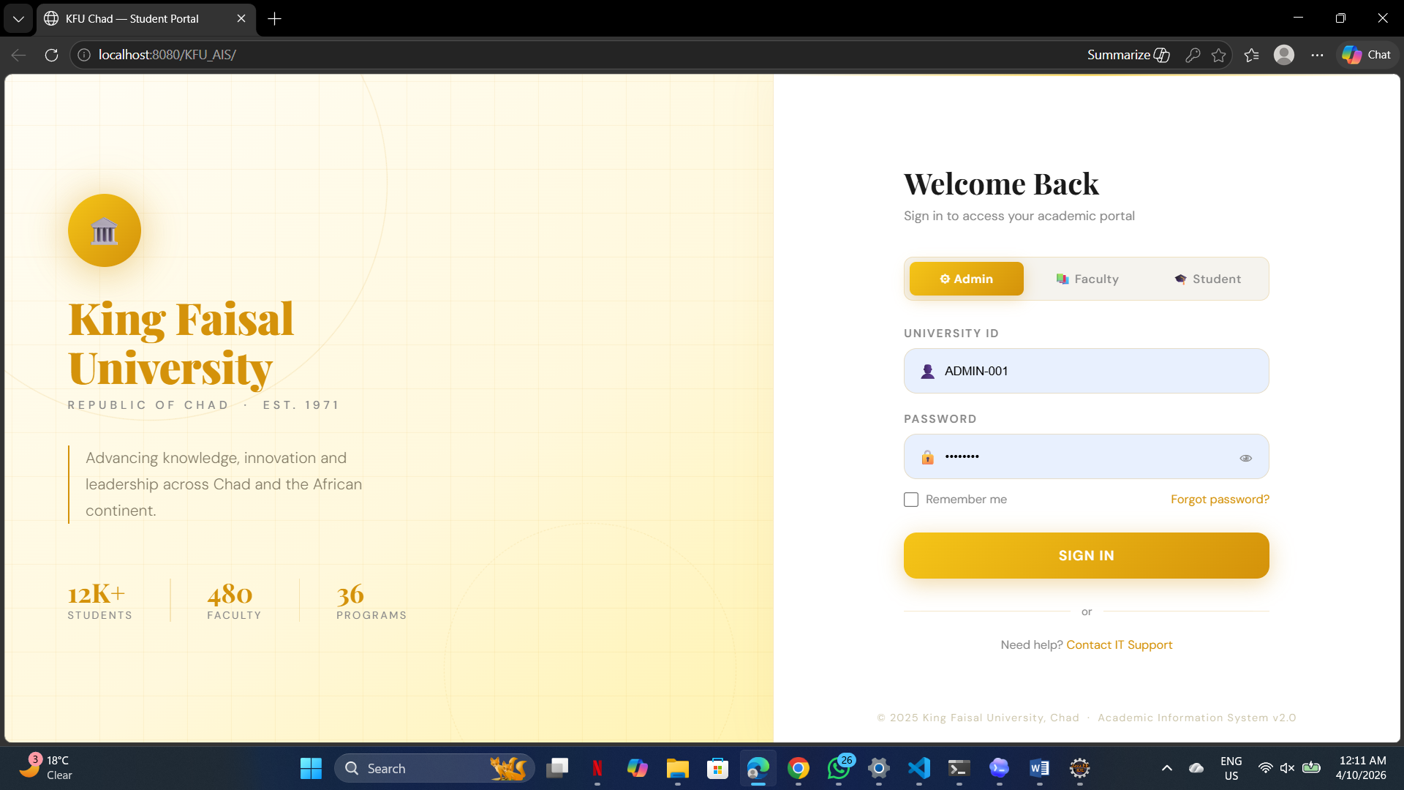Figure 4.1: KFU-AIS Login Page

4.2.2. Administrator Dashboard (Figure 4.2)
The Administrator Dashboard (admin-dashboard.html) is the most comprehensive interface in the KFU-AIS system, providing full access to all 15 functional modules. It is accessible exclusively to users authenticated with the Admin role and is protected by a server-side session guard that redirects unauthenticated access to the login page.
The dashboard layout follows a two-panel design: a fixed left sidebar navigation panel and a dynamic main content area. The sidebar contains labeled links to all administrative modules, including Student Management, Faculty Management, Course Management, Timetable, Attendance Records, Results, Assignments, Fee Management, Hostel Management, Library Management, and the Notice Board. A Logout button at the bottom of the sidebar triggers the LogoutServlet, which invalidates the session before redirecting to the login page.
The main content area loads the selected module's interface dynamically via JavaScript AJAX calls to the corresponding Servlet, without requiring a full page reload. The top of the main area displays a real-time statistics panel showing key institutional metrics fetched from DashboardServlet — including the total number of registered students, faculty members, active courses, and any unread urgent notices. Administrators can perform full CRUD operations on all entities from this interface. All data input forms include client-side validation (required field checks) and server-side validation (null checks and PreparedStatement binding) before database interaction. Error responses from Servlets are displayed inline without exposing database-level details.
Figure 4.2 below shows the Administrator Dashboard of the KFU-AIS system:
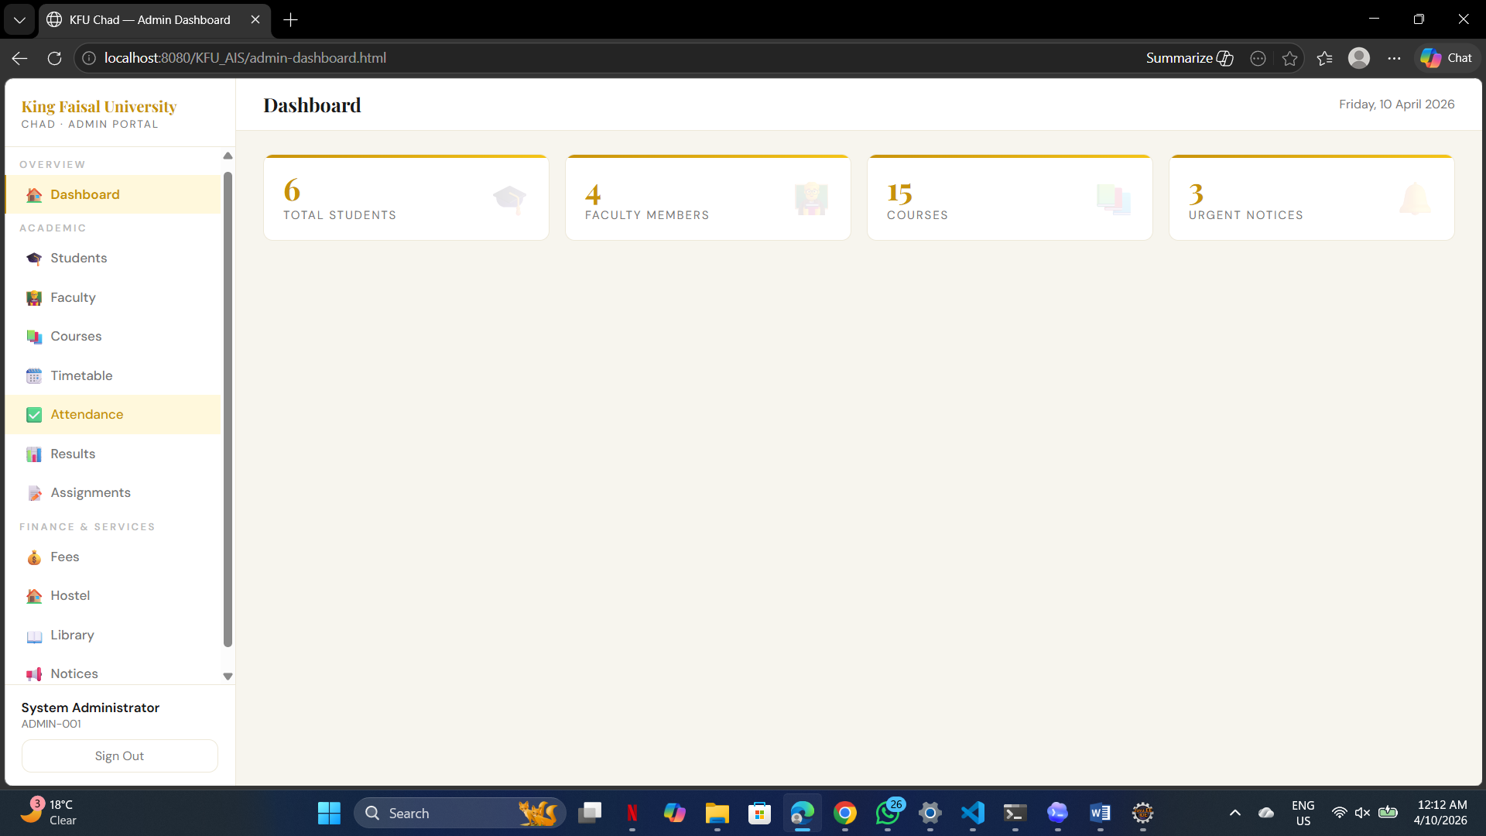Figure 4.2: KFU-AIS Administrator Dashboard

4.2.3. Faculty Dashboard (Figure 4.3)
The Faculty Dashboard (faculty-dashboard.html) provides faculty members with a role-specific interface tailored to their academic responsibilities. It is accessible only to users authenticated with the Faculty role. Like all dashboard pages, it performs a session role-check on load and redirects to the login page if the session is absent or if the role does not match.
The Faculty Dashboard follows the same two-panel layout as the Administrator Dashboard, with a left sidebar navigation and a dynamic main content area. However, the sidebar only exposes the modules relevant to the Faculty role: My Timetable, Mark Attendance, View Attendance Records, Enter Results, My Assignments, Post Assignment, View Submissions, and Notice Board. This role-restricted navigation is enforced both on the frontend (by rendering only faculty-relevant sidebar links) and on the backend (by checking the session role in each Servlet before processing requests).
The main content area displays a personalized welcome panel showing the faculty member's name, department, designation, and qualification — fetched from DashboardServlet using the faculty_id stored in the session. The Timetable module displays only the schedule slots assigned to the logged-in faculty member (filtered by faculty_id in TimetableServlet), not the full institution timetable. The Attendance module allows the faculty to select a course and date, then mark each enrolled student's status as Present, Absent, Late, or Excused. The Assignment module allows the faculty to post new assignments (with title, description, due date, and maximum marks) and view all submissions received for each assignment, including the student's remarks. The Results module allows the faculty to enter internal and external marks for each student per course, with the system automatically computing the total, assigning the letter grade, and calculating the grade point.
Figure 4.3 below shows the Faculty Dashboard of the KFU-AIS system:
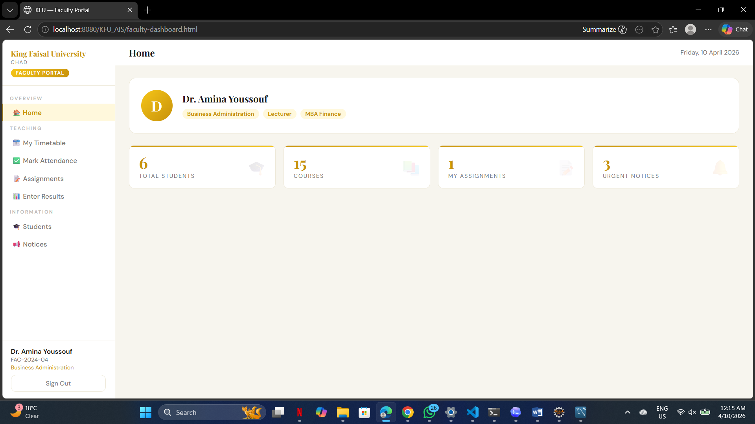Figure 4.3: KFU-AIS Faculty Dashboard

4.2.4. Student Dashboard (Figure 4.4)
The Student Dashboard (student-dashboard.html) provides students with a read-oriented, personalized academic portal. It is the most access-restricted of the three dashboards, exposing only student-specific data views with no create, update, or delete capabilities except for submitting assignments. Access is protected by a server-side session guard that checks for the Student role on every page load.
The Student Dashboard sidebar includes links to: My Profile, My Timetable, My Attendance, My Results, Assignments & Submissions, My Fees, My Hostel, My Library Issues, and Notice Board. The main content area opens with a personalized academic summary panel displaying the student's name, department, semester, enrollment date, and three key performance indicators: current attendance percentage, Cumulative GPA (CGPA), and total pending fee amount — all fetched in real time from DashboardServlet using the student_id stored in the session.
The Attendance module displays the student's complete attendance history across all courses, showing the date, course, and status (Present/Absent/Late/Excused), along with a calculated overall attendance percentage. A highlighted warning message is displayed if the attendance percentage falls below the 75% institutional threshold, alerting the student to take corrective action. The Results module displays all recorded marks and grades per course per semester, along with the automatically computed CGPA across all completed courses. The Assignments module lists all active assignments posted by faculty for the student's enrolled courses, with their due dates and maximum marks; the student can submit each assignment directly through the portal with optional remarks. The Fees module shows the student's complete fee history — including fee type, amount in CFA Francs, due date, and payment status (Paid/Unpaid) — for financial transparency. The Hostel module displays the student's currently allotted room details including block, floor, room type, and monthly fee. The Library module shows all currently issued books with their due dates and any accumulated overdue fines at the rate of 50 CFA Francs per day.
Figure 4.4 below shows the Student Dashboard of the KFU-AIS system:
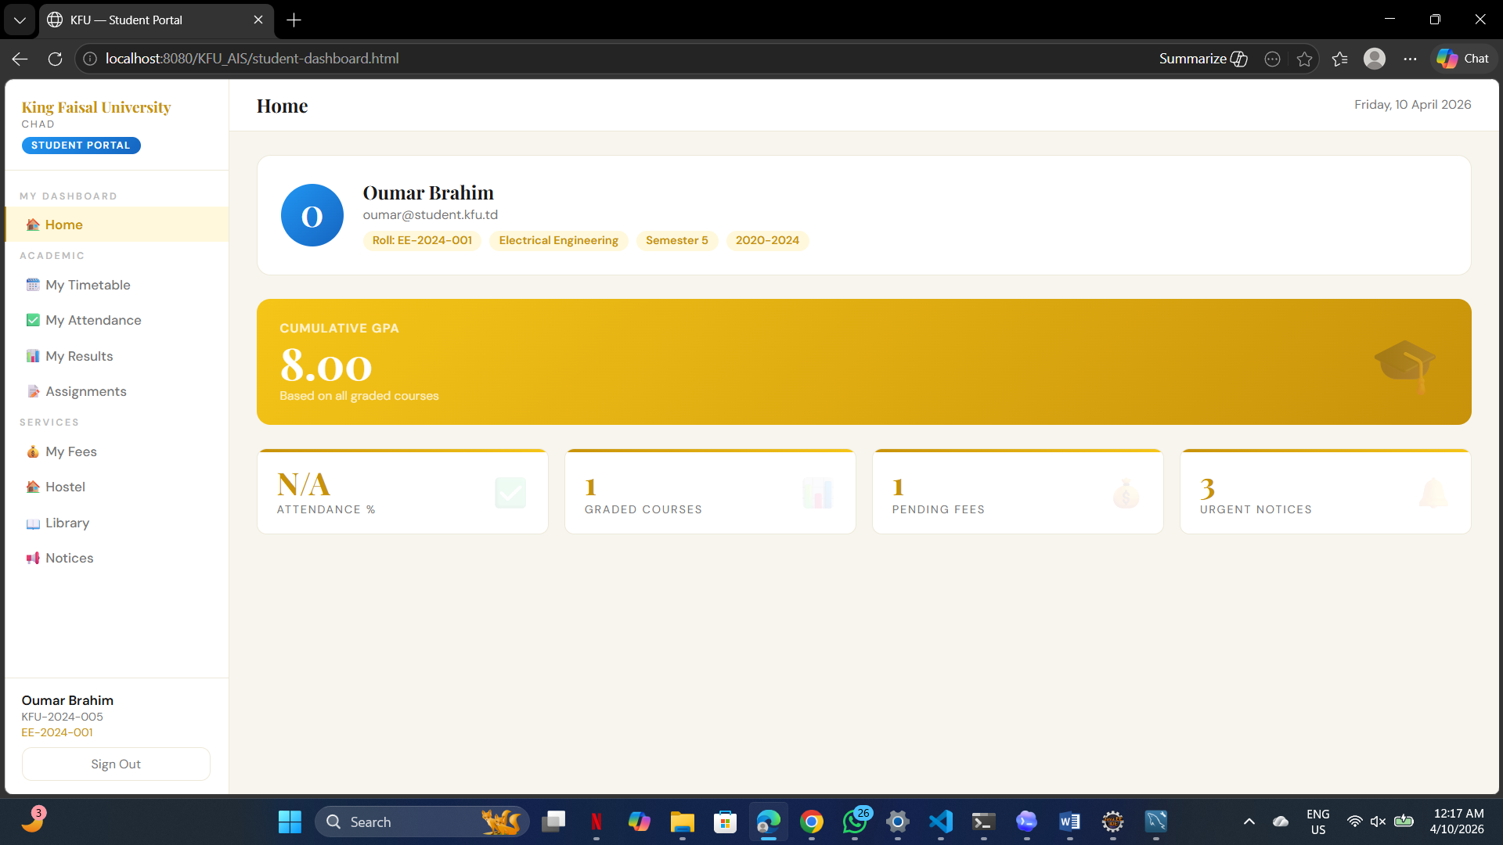Figure 4.4: KFU-AIS Student Dashboard

CHAPTER 5. CONCLUSION AND FUTURE WORK

5.1. Conclusion
KFU-AIS v2.0 has been successfully designed, developed, and validated as a comprehensive, full-stack web-based Academic Information System for King Faisal University, Republic of Chad. The system fulfills all stated objectives: it centralizes 15 core university functions into a single secure portal, enforces role-based access for Administrators, Faculty, and Students, ensures data integrity through a normalized 16-table MySQL database with 22 foreign key constraints, and provides robust security through SQL injection prevention, session management, and transactional operations.
The choice of Jakarta Servlets with pure HTML/CSS/JavaScript — avoiding heavy frontend frameworks — ensures the system is lightweight, fast, and deployable in the low-bandwidth environment of Chad. The MVC architecture ensures clean separation of concerns and maintainability. All 15 modules were implemented, tested, and validated successfully.
This project demonstrates that a full-featured university management system can be built entirely with core Java EE technologies without reliance on expensive commercial software, making it a cost-effective and sustainable solution for resource-constrained academic institutions in the African context.

5.2. Future Work
The following enhancements are recommended for future versions of KFU-AIS:
- BCrypt Password Hashing: Implement BCrypt (already recommended in the security specifications) to replace plain-text password storage before production deployment.
- Mobile-Responsive Frontend: Redesign the HTML dashboards with responsive CSS to support access from smartphones and tablets — critical for student use in Chad.
- Email Notification System: Integrate JavaMail API to send automated email notifications for fee due dates, attendance warnings, assignment deadlines, and new notices.
- Online Fee Payment Integration: Integrate a mobile money payment gateway (e.g., Airtel Money or Orange Money API) to support digital fee payment, which is the dominant payment method in Chad.
- Multi-Language Support (French/Arabic): Add internationalization (i18n) support for French and Arabic interfaces, the primary languages of instruction at KFU.
- Report Generation: Implement PDF report generation (using iText or Apache PDFBox) for student transcripts, fee receipts, attendance reports, and timetable exports.
- REST API Layer: Refactor Servlet responses to a standardized RESTful API to enable future mobile app development.
- Exam Scheduling Module: Add an examination scheduling module to manage seat allocation, exam timetables, and invigilation assignments.
- Analytics Dashboard: Implement an analytics module for administrators to visualize trends in attendance, results, and fee collection using chart libraries.

REFERENCES
[1] Oracle Corporation. (2024). Jakarta EE 10 Servlet API Specification. Retrieved from https://jakarta.ee/specifications/servlet/6.0/
[2] MySQL Documentation Team. (2024). MySQL 8.0 Reference Manual. Oracle Corporation. Retrieved from https://dev.mysql.com/doc/refman/8.0/en/
[3] Apache Software Foundation. (2024). Apache Tomcat 10.1 Documentation. Retrieved from https://tomcat.apache.org/tomcat-10.1-doc/
[4] Eze, M. O., Ugwu, C. I., & Okezie, C. A. (2019). Design and Implementation of a University Academic Information Management System. International Journal of Advanced Research in Computer Science, 10(3), 45–52.
[5] Olatunde, A. B., & Fagbola, T. M. (2020). A Web-Based Student Information System for Developing Countries: Challenges and Design Considerations. African Journal of Computing & ICT, 13(2), 21–33.
[6] Fowler, M. (2002). Patterns of Enterprise Application Architecture. Addison-Wesley Professional.
GitHub Link
https://github.com/mahamatkher/Advance-Internet-Programming-Lab-/tree/main

Screenshot
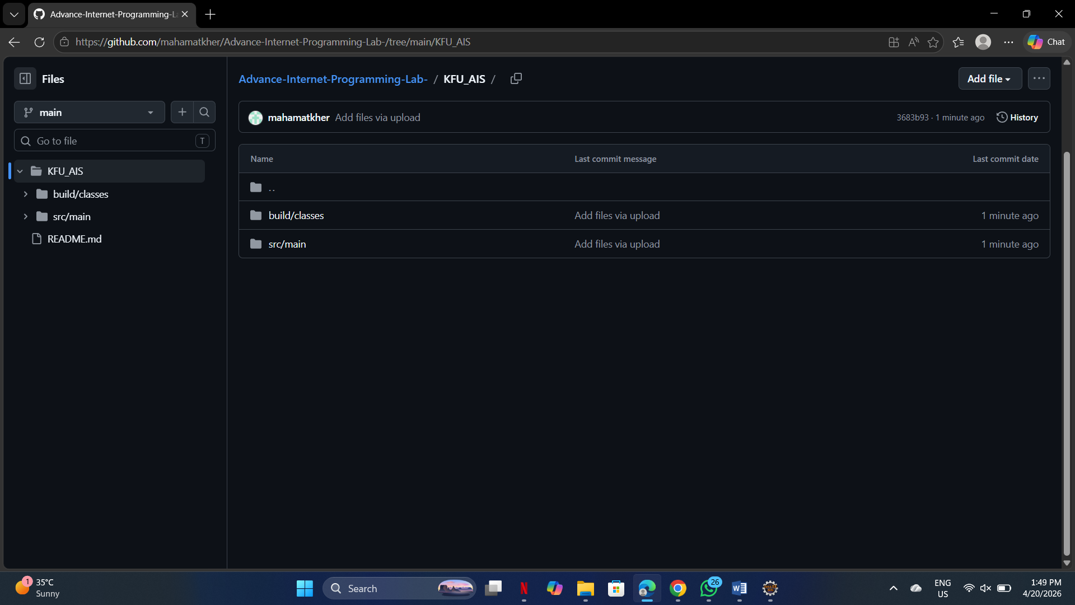

APPENDIX

1. Plagiarism Report
A plagiarism check was performed on this report using [Plagiarism Detection Tool]. The similarity index was found to be within the acceptable threshold of [X]%. The plagiarism report is attached below.
[Attach Plagiarism Report Here]

2. Design Checklist
- Database schema designed with full normalization and foreign key constraints.
- All Servlets use PreparedStatement for SQL injection prevention.
- All multi-step DB operations wrapped in transactions with rollback.
- Role-based access enforced at the Servlet level for all endpoints.
- Session management validated: unauthenticated access redirected to login.
- XSS prevention validated through safe() JSON escaping method.
- Attendance unique constraint validated for duplicate prevention.
- Library stock tracking validated for issue/return/overdue flows.
- Hostel occupancy guard validated for full-room rejection.
- Cascade delete validated across all 6 related tables for student deletion.
- HTTP error codes validated: 400, 401, 404 for appropriate scenarios.

USER MANUAL

System Requirements
- Java 21 (JDK)
- Apache Tomcat 10.1
- MySQL 8.0
- Eclipse IDE for Enterprise Java (or any IDE supporting Dynamic Web Projects)
- MySQL Connector/J 9.6.0 JAR

Setup Instructions
- Import kfudb.sql into MySQL using MySQL Workbench or the command: mysql -u root -p < kfudb.sql
- Create a new Dynamic Web Project in Eclipse and target Apache Tomcat 10.1 as the runtime.
- Place all .java files under src/main/java/
- Place all .html files (login.html, admin-dashboard.html, faculty-dashboard.html, student-dashboard.html) under src/main/webapp/
- Place web.xml under src/main/webapp/WEB-INF/
- Place mysql-connector-j-9.6.0.jar under src/main/webapp/WEB-INF/lib/
- Right-click the project in Eclipse → Run on Server → Select Tomcat 10.1.
- Open a browser and navigate to: http://localhost:8080/KFU_AIS/

Login Instructions
On the login page, enter your User ID and Password. The system will authenticate your credentials and redirect you to your role-specific dashboard (Admin, Faculty, or Student). Use the default credentials provided in Table 3.6 for initial testing.

Module Navigation
All dashboard pages contain a navigation sidebar on the left with links to all available modules for your role. Click any module name to load its interface in the main content area. All data operations are performed via AJAX without page reloads. Use the Logout button at the bottom of the sidebar to securely end your session.

